A RECURSIVE VERSION OF FLOYD-WARSHALL ALGORITHM

By

Tolga Tosun

Submitted to

The University of Liverpool

MASTER-OF-SCIENCE-DATA-SCIENCE-AND-ARTIFICIAL-INTELLIGENCE

CSCK541 Software Development in Practice March 2023 A

Word Count: 1205

30/04/2023

A RECURSIVE VERSION OF FLOYD-WARSHALL ALGORITHM

Submitted to

The University of Liverpool

Word Count: 1205

30/04/2023

TABLE OF CONTENTS

Page

LIST OF FIGURES 4

Chapter 1. Introduction 5

Chapter 2. Floyd-warshall algorithm 5

Chapter 3. Recursive version of floyd-warshall algorithm 7

3.1 Getting An Input 7

3.2 Creating the Input Graph 9

3.3 Printing The Graphs 9

3.4 Recursive Floyd-Warshall Algorithm 10

Chapter 4. Unit Tests 12

Chapter 5. Time Performance 13

Chapter 6. Complexity Performance 13

REFERENCES 14

LIST OF FIGURES

Page

Figure 1. Illustrative representation of initial status of a graph including its nodes and distance between nodes 6
Figure 2. Illustrative representation of all paths from node 1 to node 4 6
Figure 3. Execution part of the recursive version of Floyd-Warshall algorithm 7
Figure 4. The “get_user_input” function 8
Figure 5. The “graph_creator” function 9
Figure 6. The “print_graph” function 10
Figure 7. Flow chart of the “floyd” function 11
Figure 8. The “floyd” function 12
Figure 9. The result of the “comparison” function 13

Introduction
The Floyd-Warshall algorithm is a well-known graph algorithm used to find the shortest distance between all pairs of nodes in a weighted graph using a dynamic programming methodology. The algorithm, which uses a weighted graph as an input, calculates all the possible direct or indirect (through an intermediate node) paths from the start node to the end node. It then finds the shortest one and updates the solution matrix.
This report provides an in-depth analysis of the recursive implementation of the algorithm, including its structural components. It also elucidates the unit testing process performed for the recursive algorithm. Furthermore, the report examines the performance characteristics of the recursive and iterative versions of the algorithm concerning execution time and complexity.

Floyd-warshall algorithm
The iterative version of the Floyd-Warshall algorithm utilizes a two-dimensional matrix of size VxV, where V represents the number of vertices in the graph, to find the shortest distances between every pair of nodes in the matrix. Firstly, the solution matrix is filled with the weights of the edges in the graph. If a pair does not have any edge between its nodes, the weight is set as infinite. The algorithm then iterates for each intermediate, start and end nodes, respectively, considering all the possible paths until it finds the shortest distance between the nodes. When the algorithm finds the shortest distance, it updates the distance matrix (Habib et al., 2023).
For instance, the shortest distance from node 1 to node 4 in the graph, as presented in Figure 1, can be calculated by the Floyd-Warshall algorithm. Firstly, the algorithm finds all the possible paths between node 1 to node 4, as shown in Figure 2. It then selects the shortest path, the one through node 2 and node 3 and the distance is 6. The path is highlighted in red in Figure 2.
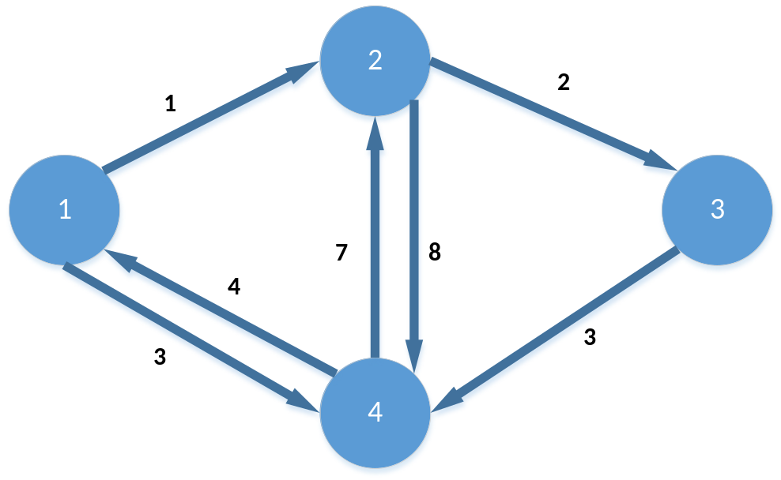
Figure 1. Illustrative representation of initial status of a graph including its nodes and distance between nodes
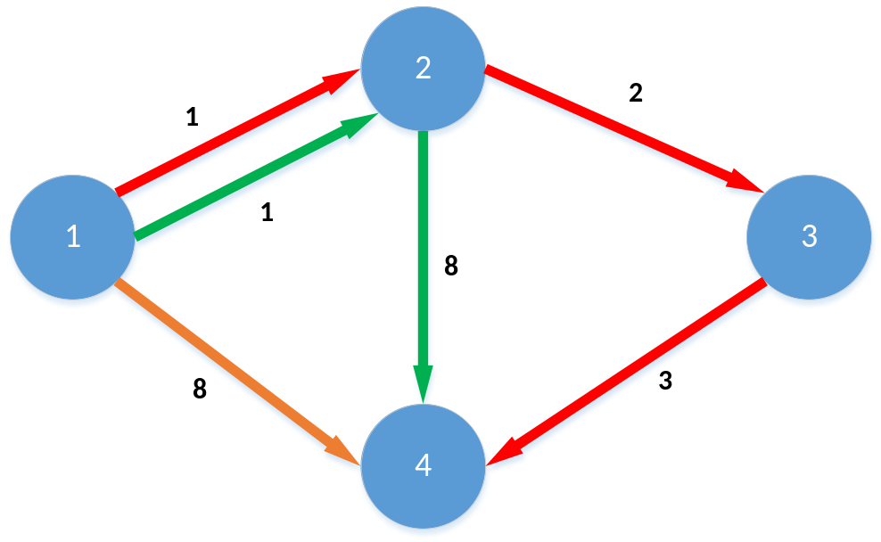
Figure 2. Illustrative representation of all paths from node 1 to node 4

Recursive version of floyd-warshall algorithm
The module named “floyd_recursion” first takes input from the user as the range of a graph. The “graph_creator” function then generates the graph. And then, the graph is printed to provide a visual understanding for the user. The “floyd” function takes the graph and GRAPH_RANGE as its input. After the function finds all the possible paths and their distances, it updates the “distance” matrix with the shortest path. Lastly, the function prints the solution by calling the “print_graph” function.
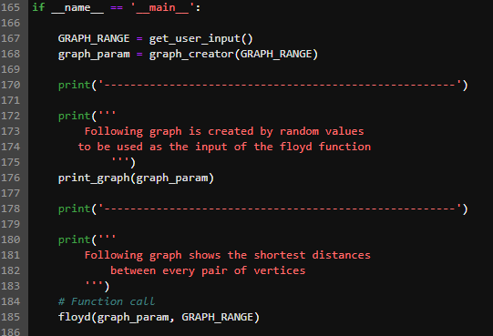
Figure 3. Execution part of the recursive version of Floyd-Warshall algorithm

Getting An Input
Initially, the module invokes the "get_user_input" function, prompting the user to provide input. The function then attempts to convert the input to an integer. If the conversion process fails, a customized error message "Graph range must be an integer value" is raised, and the system exits. On the other hand, if the input is successfully converted to an integer, the function validates whether the integer is positive or not. This check is necessary as a graph's size cannot be negative. If the input is negative, the system generates an error message "Graph range cannot be a negative integer", and exits. If the input is positive, the function returns the input as graph_range.
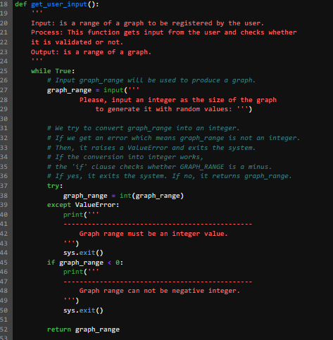
Figure 4. The “get_user_input” function

Creating the Input Graph
Firstly, the "graph_creator" function accepts the graph_size parameter provided by the "get_user_input" function. This function defines an empty graph and a values list that includes NO_PATH and numbers from 1 to 10. The NO_PATH variable has already been defined as a global variable in the module. The function then iterates through loops to create all the columns and rows of the graph. If the column and the row are the same nodes in the matrix, their distance is set to zero. Otherwise, a random value is chosen from the values list. The function updates the column for the first row and then repeats the same process iteratively. Finally, the function returns the generated graph.
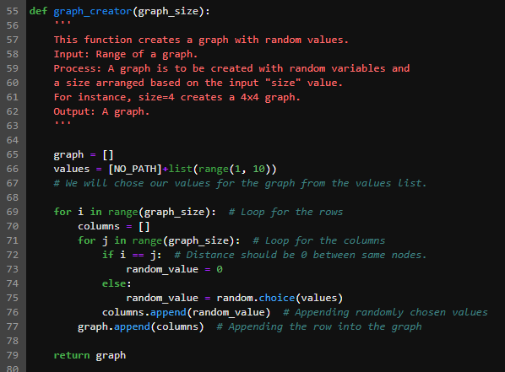
Figure 5. The “graph_creator” function

Printing The Graphs
The module includes a modified version of the "print_graph" function sourced from geeksforgeeks (Floyd Warshall Algorithm | DP-16, 2023). The function accepts a matrix as input and iterates through rows and columns using two loops. If the value is equal to the predefined constant "NO_PATH" (represented as 999,999), the function replaces the value with a string literal "NO_PATH". Otherwise, the function prints the original value.
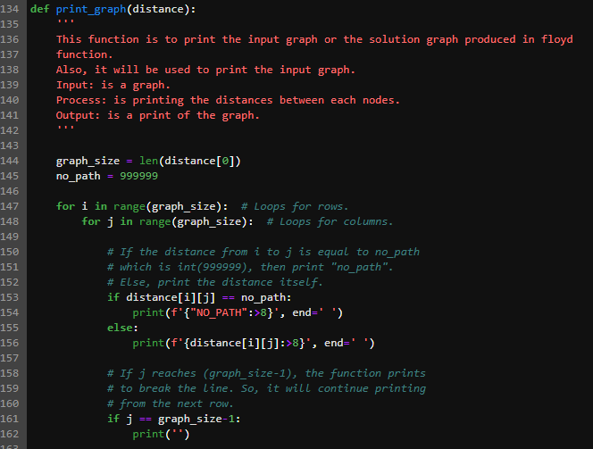
Figure 6. The “print_graph” function

Recursive Floyd-Warshall Algorithm
The "floyd" function calculates the shortest distance between nodes in a graph. It takes a graph and graph_range (size of the graph) as inputs and initializes intermediate_node to zero in the first call.
As depicted in Figure 7, if intermediate_node is less than graph_range, the function iterates through each start_node and end_node in nested loops. If the actual distance from start_node to end_node is greater than the distance through an intermediate_node, the distance matrix is updated with the indirect value in the iteration. Otherwise, the actual distance is kept. The function then calls itself again with the updated distance matrix, graph_range, and intermediate_node incremented by 1.
This recursive calling continues until intermediate_node reaches the graph_range. Finally, the "print_graph" function is called to print the resulting matrix.
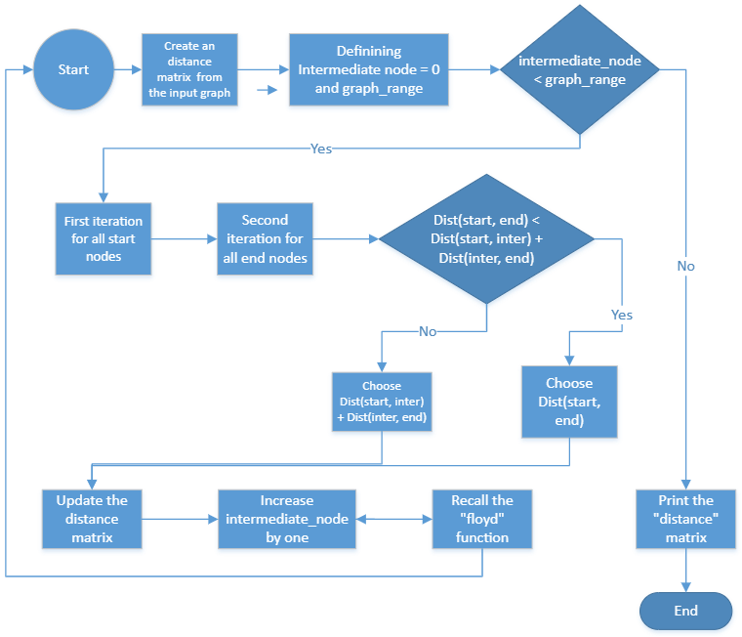

Figure 7. Flow chart of the “floyd” function

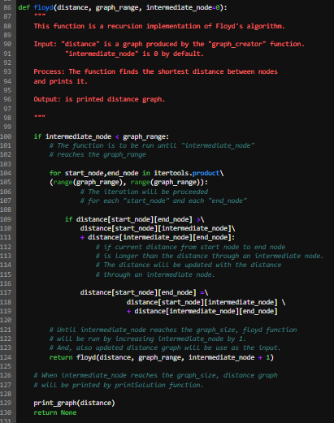
Figure 8. The “floyd” function

Unit Tests
The "test_floyd_recursion" module includes unit tests for the functions from the "floyd_recursion" module. The module begins by defining a capturing class to collect the printed output from the functions. The patch decorator (StackOverflow, 2021) is used to simulate user input for the testing process. The "get_user_input" function is tested by providing input of 5, "This is a string!", and a negative integer. Firstly, the function should proceed successfully with 5.
However, the other two tests expect a warning to be raised and the program to exit.
The "graph_creator" function is tested to ensure that it generates a zero distance for the same nodes to pass the "test_same_nodes_zero_dist" test. The next test function compares the printed output of the "print_graph" function with a provided matrix. Lastly, the "floyd" function is tested by providing a matrix as input and verifying that the printed output matches the expected result.
In total, the module includes 7 successful unit tests.

Time Performance
The time performance of the iterative and recursive version of the Floyd-Warshall algorithm is performed by first creating 10,000 graphs containing random values from 1-10 and NO_PATH. Since the functions print the outputs, the “Capturing” class (StackOverflow, 2022) is used to capture outputs, not to print them. And then, the total start and end times of the solutions of the 10,000 graphs are measured. Lastly, the “comparison” function compares the results, as seen in Figure 8. Hence, even if the comparative results show that the iterative version is from 7% to 12% faster than the recursive version, the iterative version is average 10% faster.
Figure 9. The result of the “comparison” function

Complexity Performance
GeeksforGeeks explains the time complexity of the iterative version as O(V3). Since the iterative version includes the loops for start, intermediate and end nodes, the time complexity equally increases. On the other hand, the recursive version has the same time complexity.
The "complexity_comparison" module compares the time complexity between the iterative and recursion versions. While the iterative version creates three loops for the intermediate, start and end nodes, the recursive version creates two loops only for the start and end nodes. However, since the recursive version calls the function as many times as the number of the intermediate nodes, they both hit the loops 64 times for a 4x4 matrix.
In the recursive version, there is extra work that the computer has to do to keep track of the function calls. Mainly, each function call in the recursive version requires that the programme's current state be saved on the stack to be resumed when the recursive call returns. This creates additional overhead for the computer, as it must allocate memory for the stack and perform additional bookkeeping operations to manage the call stack. On the contrary, the iterative version does not require this overhead, so it performs its work using three simple loops (AfterAcademy, 2019) (Panigrahi, 2023).

REFERENCES
AfterAcademy (2019) Available at: https://afteracademy.com/blog/what-is-the-difference-between-iteration-and-recursion/ (Accessed: 29 April 2023).
Floyd Warshall Algorithm | DP-16 (2023) Available at: https://www.geeksforgeeks.org/floyd-warshall-algorithm-dp-16/ (Accessed: 29 April 2023).
Habib, S. et al. (2023) ‘Floyd-Warshall Algorithm Based on Picture Fuzzy Information’, Computer modeling in engineering & sciences, pp. 1–22. Available at: https://doi.org/10.32604/cmes.2023.026294.
Panigrahi, K.K. (2023) Difference Between Recursion and Iteration. Available at: https://www.tutorialspoint.com/difference-between-recursion-and-iteration (Accessed: 23 April 2023).
StackOverflow (2021) Available at: https://stackoverflow.com/questions/18161330/using-unittest-mock-to-patch-input-in-python-3 (Accessed: 29 April 2023).
StackOverflow (2022) Available at: https://stackoverflow.com/questions/16571150/how-to-capture-stdout-output-from-a-python-function-call (Accessed: 29 April 2023).

